**JENKINS PROCESS FOR FOUNDATION-FRONTEND**

**Step 1: Jenkins Setup**

* Open Jenkins and navigate to "Manage Jenkins".
* Click on "Global Tool Configuration" and add Docker.
* Go to "Manage Plugins" and install necessary plugins for Docker integration.

**Step 2: Create a New Job Setup**

* Open Jenkins and create a new job for the application.
* Select "Pipeline" as the job type and click "OK".
* Navigate to the Jenkins Dashboard and click on the created job to configure it.
* Start writing the pipeline Groovy script.
* After writing the script, click on "Apply" and then "Save".
* Once saved, navigate back to the Jenkins Dashboard and click "Build Now".
* You can view the progress of the build in the Stage View.
* Go to the build history and click on the recent build number to view details

**Step 3: Clone Repository**

* Navigate to the Jenkins Dashboard.
* Open the Jenkins pipeline job for your project.
* Execute the "Clone Repository" stage to fetch the latest code from the repository.

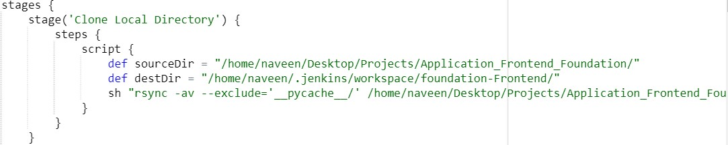

**Step 4: Check Dockerfile**

* Continue from the previous step.
* Execute the "Check Docker file" stage to ensure the Dockerfile for the backend exists.
* If the Dockerfile exists, proceed; otherwise, stop the process.
* 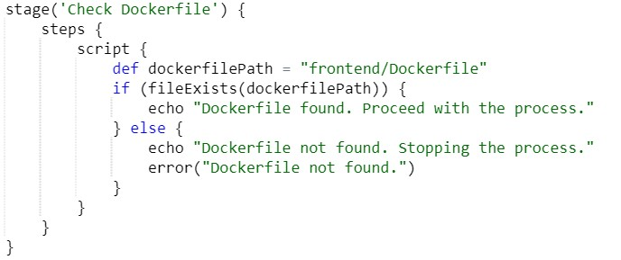

**Step 5: Build the Docker Image**

* Execute the "Build the Docker Image" stage.
* The script will build the Docker image, tag it with a timestamp, and list the Docker images.

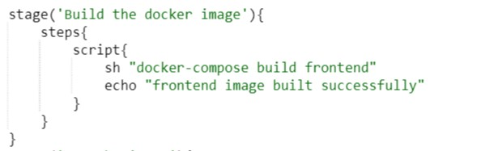

**Step 6: Run the Backend Image**

* Execute the "Run the Backend Image" stage to start the Docker container from the built image.
* The container for the backend will start in detached mode

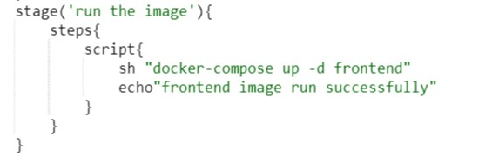

**step 6 List Docker Images:**

* This stage lists the Docker images present on the Jenkins agent.
* It uses the docker images command to display the list of images.
* After listing the images, it echoes a message indicating that the Docker images list has been displayed.

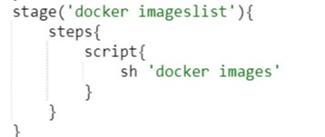

**Step 7: Curl Test**

* Execute Curl Test Stage: The final stage in the pipeline is "Curl Test".
* Perform Curl Test: Jenkins executes a curl command to test the accessibility of the frontend server running inside the Docker container.
* Display Test Result: Based on the curl output, Jenkins either confirms that the server is accessible or raises an error if the test fails.
* That's the detailed step-by-step process of the provided pipeline script. It involves setting up Jenkins, creating a pipeline job, cloning the repository, checking the Dockerfile, building and running the Docker image, listing Docker images, and performing a curl test to verify server accessibility.

